**Audit Data Analytics**

**Quarterly Summary by Service Area**

# **Overview**

Before I give you the summary view of transactions for each service area, let’s explore a high-level overview of quarter-by-quarter comparison on all the transactions in the combined dataset.

The graphs below show quarterly transaction counts and averages, together with the quarterly sums of transaction amounts. You will also see similar charts for each of the service areas in Section 1.

**Transaction Counts**

There is a drop in Q3 2016 in number of transactions, driven by lower-than-usual July 2016 and August 2016 numbers of transactions and extremely low volume of transactions in September 2016. This makes me wonder if the data is complete for Q3 2016. Let’s have it clarified it with the audit client.

Also, before visualizing these graphs, I cleaned the data and found that there were a good number of duplicated data rows. It is worthwhile to inquire the audit client about data duplication as well. This will help ensure data quality for analysis. Please be advised that I have already removed the duplicated data points.

Additionally, there can be multiple credit card transactions per journal reference. However, it is strange that some journal references have different journal dates. I would expect they have the same dates and would like to have this unusual item clarified.

**Transaction Averages**

There seems to be seasonality in the data as Q2s experienced spikes in transaction averages, roughly doubling those of Q4s. I wonder what the reasons behind this trend can be, and I would be curious to know the result of client inquiries about this. By observing the similar graphs of the service areas, you can tell which services areas are the main drivers of this seasonality.

**Total Sum of Transaction Amounts**

Except for Q3 2016 in which data completeness is questionable, there are fluctuations in aggregated transaction amounts. There are no clear signs of increasing or decreasing trends; however, we can see seasonality patterns that the total sum of transaction amounts tends to be lower in Q4s and Q1s and be higher in Q2s and Q3s.

1. **Summary View of Transactions for Each Service Area**

Among the 24 service areas, those with the largest transaction accounts are summarized first in this report, including boxplots that the auditor is familiar with. For each service area, visualizations of transaction counts, averages, and total sum of transaction amounts are provided to enable quarter-by-quarter trending analysis. I also give suggestions for unusual patterns detected so that we can inquire the audit client more about the data.

If the auditor just wants the statistics in a tabular format or each service area, please use the attached Excel sheet below.



As this is a work sample, insights into top 5 service areas are shown below instead of all the service areas.

1. **Children’s Family Services**

Each dot in the scatter plot below represents a transaction. There is a gap between March 2015 and April 2015 with no transactions noted, which would require further investigation with the audit client.

From the boxplot, we can see quite a few outliers out there. You will see similar instances in the other boxplots of the other service areas. Section 4 about anomalous transactions will provide more details of the anomalies.

It looks like the lows of transaction averages in Q4 2015 and Q1 2016 noted in the Overview section can be explained by this service area. It would be useful to inquire the audit client about the reasons behind this rapid decline and then a quick recovery in transaction average in Q2 2016.

1. **Children Services**

This service area has a huge gap in two-month data from August 2014 to the end of September 2014. I wonder what caused this discontinuation.

The timelines by journal dates, together with the names of this service area (“Children Services”) and the next service area (“Family Services”) seem to suggest that these two services areas were later combined into the service area “Children’s Family Services” mentioned above. Please note this to inquire the audit client further.

1. **Family Services**

Other than some outliers, no unusual patterns noted for this service area.

1. **Children’s Education & Skills**

There is a data gap around April 2015, and so few small transactions are noted starting April 2016.

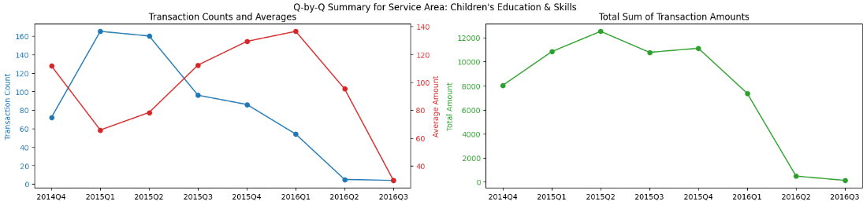

1. **Commissioning**

Similarly, a gap around April 2015 is noted.

Stay tuned for the next parts.

Thank you for reading.

Best regards,

Alex Pham, CPA